Analysis of State-Wise Installed Capacity in India (2017-2025)

Project Overview
This Power BI project analyzes the state-wise installed electricity capacity in India from 2017–2025, focusing on trends and shifts in capacity from traditional to renewable sources. The project will use interactive dashboards to visualize data, allowing users to compare state-level and national-level capacity changes, examine the growth of renewable energy (solar, wind, etc.) versus non-renewable sources, and identify states that are leading or lagging in power generation.
Objectives
- To create an interactive dashboard in Power BI to visualize and analyze the state-wise installed power capacity in India from 2017 to 2025.
- To track the overall growth in India's installed capacity and identify key drivers of this growth.
- To analyze the changing energy mix, specifically the increasing share of renewable energy sources compared to traditional thermal power.
- To compare the performance of different states in terms of installed capacity, including both total and renewable energy capacity.
- To provide insights into regional disparities in power generation capacity across India.
Key features
- Interactive dashboards: Use filters to allow users to select specific states, years, or energy source types (e.g., solar, wind, thermal, hydro).
- Time-series analysis: Visualize the year-on-year growth and trends in installed capacity for each state and the nation as a whole.
- Geographical mapping: Use a map of India to visually represent the installed capacity of each state, with color-coding to indicate capacity levels.
- Comparison charts: Use bar charts and line charts to compare the installed capacity of different states, and to compare the growth of renewable versus non-renewable sources over time.
- Key performance indicators (KPIs): Display summary metrics such as total installed capacity, percentage contribution of renewable energy, and growth rate
Data sources
Source Description and Timeline: Indian Data Portal Installed Capacity State-Wise (2017-2025)
Domain: Energy Sector
Problem Statement
"The Indian power sector has undergone significant changes from 2017 to 2025, particularly with the rapid expansion of renewable energy (RE) capacity alongside traditional thermal and hydro sources. While national-level data on total installed capacity is available, a clear, interactive, state-by-state analysis of this growth across different energy sources is needed for effective regional policy making and investment decisions.
The challenge is to consolidate fragmented data from various sources (e.g., Central Electricity Authority (CEA), Ministry of New & Renewable Energy (MNRE)) into a single, intuitive Power BI dashboard. This dashboard must enable stakeholders to analyze:
- Trends: Which states show the highest growth in overall capacity?
- Mix Shift: How has the energy mix (share of coal, solar, wind, hydro, etc.) evolved in each state?
- Performance: Which states are leading in the renewable energy transition, and which are lagging?
The objective is to provide an interactive visualization tool that offers actionable insights into regional disparities and progress toward national sustainability goals, thereby facilitating data-driven decision-making for future infrastructure planning and resource allocation."
Attribute details
Attribute | Description | Example Data
State/Union Territory | The name of the state or union territory for which the data is recorded. | "Tamil Nadu", "Gujarat", "Delhi"
Year | The specific year of the data point. | "2017", "2018", "2025"
Power Source | The type of power generation source. | "Solar", "Wind", "Coal", "Hydro"
Installed Capacity (MW) | The total installed capacity for that state, year, and power source. | 5,200 MW  (Solar, 2025)
Region (Optional) | The geographical region, which can be useful for grouping states. | "Southern", "Western", "Northern"

Tools and technology
- Data import: Use Power BI Desktop to connect to your data sources, which may include Excel files, CSVs, or databases.
- Data modeling: Build relationships between different tables, such as a time table and a capacity table, and use DAX (Data Analysis Expressions) to create new measures like percentage growth or total renewable capacity for each state.

Geographic map: Use a map of India to show state-wise capacity, with the size of the state representing its total installed capacity. You can also use color-coding to highlight the renewable energy share or growth rates.
  - Time series line chart: Plot the total installed capacity for each state over the years (2017-2025) to visualize growth trends and identify periods of rapid expansion.
  - Bar charts: Use grouped or stacked bar charts to compare the capacity mix (e.g., solar, wind, thermal) across different states. You can also create a bar chart to show the top states by installed capacity, with Maharashtra, Gujarat, and Rajasthan often leading.
  - Slicers and filters: Implement slicers for years, states, and energy sources to allow for interactive analysis. For example, a user could filter the dashboard to see the renewable capacity of Rajasthan in 2023 or the total capacity of Maharashtra in 2025.
Data Collection
The data is available in numerous monthly and yearly reports, typically in Excel or PDF formats, from government sources.
- Primary Sources:
  - Central Electricity Authority (CEA): Publishes monthly and yearly "Installed Capacity Reports" with state-wise and region-wise breakdowns for conventional (thermal, hydro, nuclear) power. These can be found on the official CEA website or the National Power Portal (NPP).
  - Ministry of New and Renewable Energy (MNRE): Provides state-wise and year-wise data for renewable energy sources (solar, wind, biomass, small hydro). Look for "Physical Achievements" or "Energy Statistics" reports .
- Time Frame: You will need to download reports covering the period from financial year 2017-18 up to the most recent data in 2025.
- Data Format: The data is often spread across multiple files or tables, requiring consolidation.
Data Preprocessing Steps in Power BI (using Power Query Editor)
Once you import the data files into Power BI, use the "Transform data" option open Power Query Editor.
A. Data Structuring and Consolidation
- Combine Files: If data is in multiple annual files, use Power Query's "Combine Files" feature to append them into a single, comprehensive table.
- Unpivot Columns: The raw data tables are often formatted for presentation (e.g., years as column headers, states as rows). You'll need to use the Unpivot Columns function to transform the data into a long, analytical format with columns for 'State', 'Year/Month', 'Source Type', and 'Installed Capacity (MW)'.
- Merge/Join Tables: Combine conventional and renewable energy datasets using the Merge Queries function, aligning them by 'State' and 'Year/Month' to create a unified dataset.
B. Data Cleaning and Transformation
- Handle Missing Values: Identify and address null or missing values. Depending on the context, you might replace them with zero (if capacity was indeed zero) or use other methods (e.g., interpolation).
- Standardize Data Types: Ensure all columns have the correct data type: 'State' and 'Source Type' as text, 'Year/Month' as date, and 'Installed Capacity (MW)' as a whole or decimal number.
- Standardize Units: Confirm all capacity figures are in the same unit (e.g., MW). Some reports may use GW, which requires conversion (1 GW = 1000 MW).
- Remove Duplicates and Irrelevant Data: Filter out any duplicate rows or irrelevant columns (e.g., total national summaries if you need state-level data).
- Rename Columns: Ensure all column headers are descriptive and consistent (e.g., Capacity MW instead of Col1, State Name instead of States / UTs).
C. Feature Engineering (Creating Custom Columns)
- Date Hierarchy: Extract 'Year' and 'Month' from the date column to enable time-series analysis and slicing in your final dashboard.
- Fuel Categories: Create a higher-level 'Fuel Category' column (e.g., 'Fossil Fuel', 'Renewable', 'Nuclear') to group sources for high-level analysis.
3.Data Modeling
After cleaning in Power Query, load the data into Power BI Desktop.
- Define Relationships: If you use separate tables for different data dimensions (e.g., a 'States' dimension table with region information), define the relationships between your fact table (installed capacity data) and dimension tables.
- Create Measures: Use Data Analysis Expressions (DAX) to create meaningful measures, such as Total National Capacity (MW), Renewable Share (%), or Year-over-Year Growth.
By following these data collection and preprocessing steps, you will have a clean, structured dataset ready for visualization and analysis in Power BI.

Data Modelling and DAX (Power BI)
Data Modelling: In data modelling, a Calendar Table was created and linked to the main dataset using the Date field to enable time-based analysis and trend visualization.

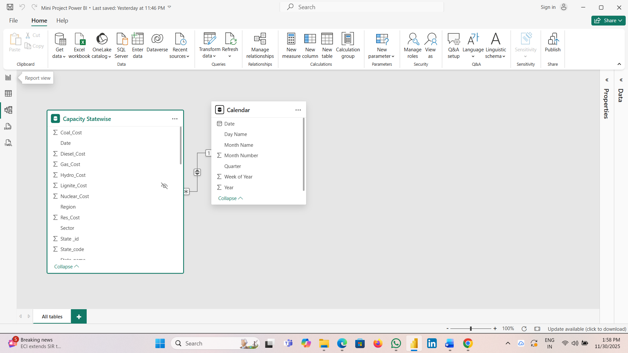
Calculated Columns, Calculated Table and DAX Measures:
Using DAX (Data Analysis Expressions), several calculated columns, Calculated Table, Measures were created to enhance analytical insights.
DAX Components Created:
Calculated Columns
- Region and State
Calculated Table
- Calendar Table
- Measured Table
Measures:
- Total Coal, Cost, Other Renewable Sector
- Total Coal, Cost, Other Renewable Sector by Region
- Total Coal, Cost, Other Renewable Sector by Year
Analysis and Visualizations (Power BI)
To address the identified problem statements, a series of interactive Power BI visualizations were developed. Various charts such as bar charts, line graphs, donut charts, tree maps, and KPI cards were used to analyses daily renewable Sector
generation –Coal, Gas, Other Renewable Sector.

- To analysis Total Coal Cost across different Region bar charts were used to identify the high energy generation and compare performance across Region.
- To analysis, Coal , Gas, Hydro, Central Table View
- created to visualize Total Coal Cost Card View.
- To evaluate Other Coal Cost and Quarter Wise Donut Charts.
- To compare the performance of Coal Cost Sector Wise using Line charts were utilized to represent and analysis.
- To identify which attract the most Coal Cost, a combination of slicers, Area Charts, funnel charts, and tree maps was used to provide interactive Region-wise analysis.
- To Analyses Total Coal Cost ,Central, State, Private by State Name using Button Slicers visualization.
- To Compare the Coal Cost by Month Name by using Scatter Chart, Ribbon chart, Donut Chart, Pie Chart was used to which month generate high Sector Cost
- Toal Gas Sector Using to, Line And Clustered Colum charts, Water Fall Carts, Decomposition Tree, Line Charts, Tree map, Slicers, Card
- Total Hydro Sector Using Funnel Chart, Map Chart, Pie Charts ,Rippon Chart, Scatted Area Chart, Card and Slicers ,Muliti Row Card and Visualization.

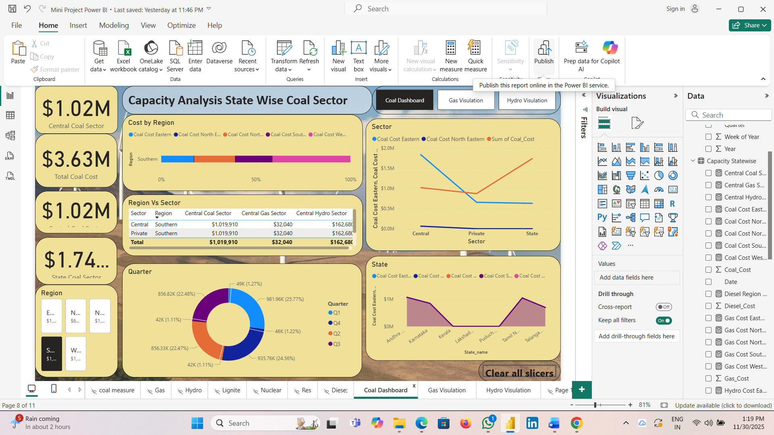
Insights Of Coal Sector

- At $1837720, Central had the Highest Coal Eastern and was 191.64% Higher than State. Which had the lowest Coal Cost Eastern at $630.130.
- Coal Cost Eastern and total Coal Cost North Eastern are Positively correlated with each other,
- Central Accounted for 58.84% of Coal Cost Eastern.
- Central had $1837720 Coal Cost Eastern $62750 Coal Cost North Eastern, and 1019910 sum of coal Cost, Private had $655,591 Coal Cost Eastern, Coal Cost North Eastern And 870972 sum of Coal cost. State had $630,130 Coal Cost Eastern, and 1739988 sum of coal cost.
- Sum of coal cost and sum of Year diverged the most when the Quarter was Q1, when sum of coal were 933445 higher than sum of year.

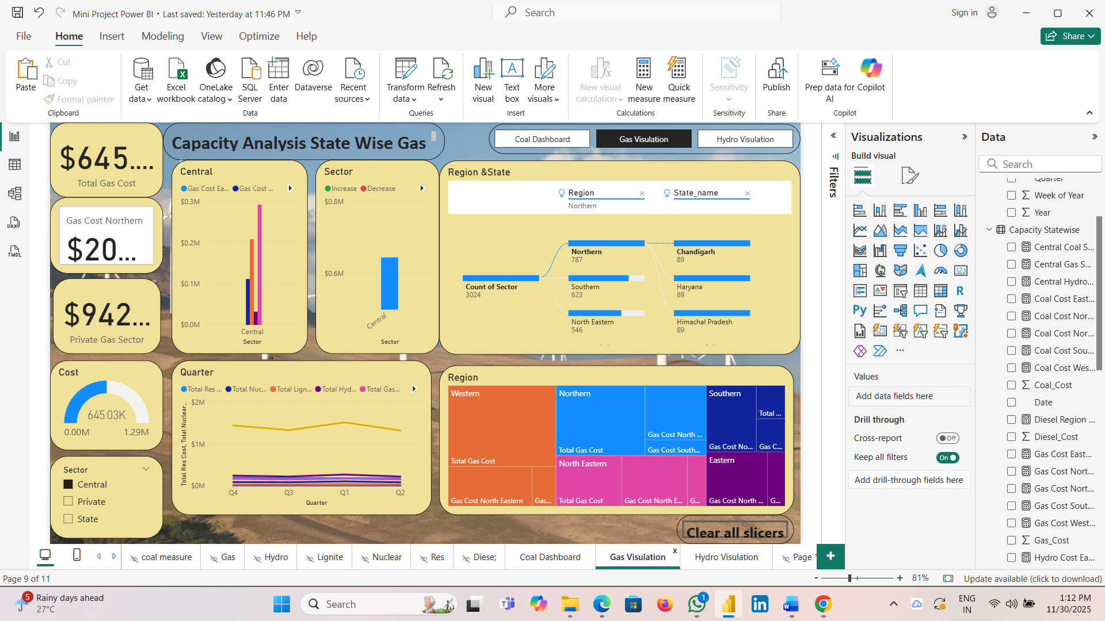
Insights Gas Sector
- Gas Cost Eastern $40565 and Total Gas Cost North Eastern $256231 Gas Cost Northern. Private Gas cost Eastern $1104 Gas Cost North Eastern, and $54,156 Gas Cost Northern. State had $8200 are negatively correlated with each other.
- Central had Gas Cost Eastern $111606 Gas Cost North Eastern ,and $208616 Gas Cost Northern.
- State Accounted for 100% of gas Cost Eastern.

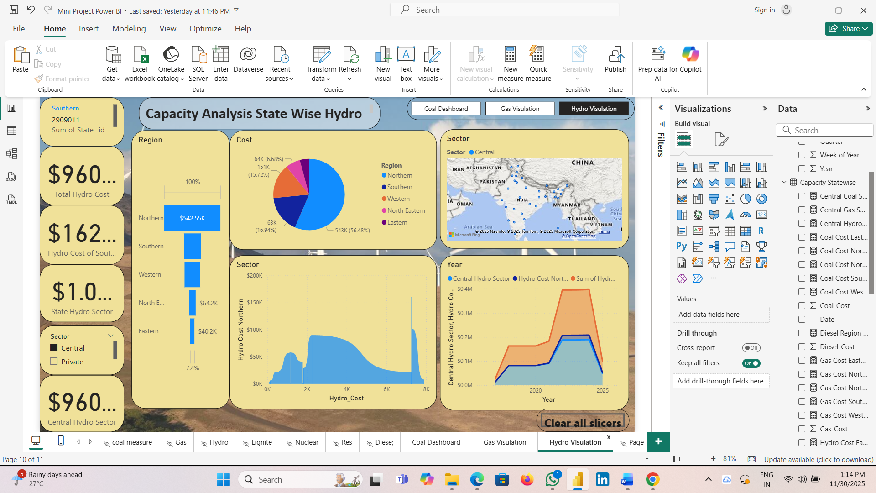
Insights Of Hydro Sector
- At $9852, had the Highest Hydro Cost Northern and was infinity higher than Which had the lowest Hydro Cost Northern at
- 7266 accounted for 29.46% of Hydro Cost Northern.
- Across all 13 hydro Cost , Hydro Cost Northern ranged from $159852.
- Central hydro Sector and total Hydro Cost northern Eastern are positively Correlated with each other.

Conclusion
Analysis of India's state-wise installed power capacity (2017-2025) reveals a significant national growth trend, particularly in renewables, with states like Gujarat, Maharashtra, and Rajasthan leading in overall capacity.
The conclusion is that India's power sector has expanded dramatically, with the total installed capacity surpassing 500 GW by late 2025, driven by substantial renewable Sector additions and increased thermal capacity, although challenges remain in grid integration for variable sources.

.

